TWIN CITIES CHAMPIONSHIP

Year Champion Site
1992 Bill Ziegler, Theo Wirth GC Theo Wirth GC
1993 Chris Brown, Theo Wirth GC Theo Wirth GC
1994 Charlie Baker, Theo Wirth GC Colombia GC
1995 Paul Commers, Theo Wirth GC Theo Wirth GC
1996 Tom Dargay, Elm Creek GC Theo Wirth GC
1997 Paul Commers, Theo Wirth GC Theo Wirth GC
1998 Nick Martindale, Gross GC Theo Wirth GC
1999 Greg Jamieson, Columbia GC Theo Wirth GC
2000 Paul Commers, Theo Wirth GC Theo Wirth GC
2001 David Isaacson, North Oaks Bunker Hills and Theo Wirth GC
2002 John Anderson, Bunker Hills GC Bunker Hills and Theo Wirth GC
2003 Jeff Berthiaume, Baker National GC Rush Creek GC and Keller GC
2004 Eric Duetsch, Soldiers Memorial Field GC Rush Creek GC and Keller GC
2005 Bob Patrick, Rush Creek GC Baker National GC and Keller GC
2006 Ralph Baxley, Valleywood GC Edinburgh GC and Keller GC
2007 Ross Hammann, Brackett’s Crossing GC Edinburgh GC and Keller GC
2008 Gus Kellom, Rush Creek GC Edinburgh GC and Keller GC
2009 Sammy Schmitz, Edinburgh USA Bunker Hills GC and Keller GC
2010 Ryan Peterson, Cannon GC Bunker Hills GC and Keller GC
2011 Tim Hamm, Rush Creek GC Bunker Hills GC and Keller GC
2012 Dylan Gergen, Mendakota CC Bunker Hills GC and Keller GC
2013 Sammy Schmitz, Valleywood GC Bunker Hills GC and Hastings CC
2014 Dylan Gergen, Mendakota CC Bunker Hills GC and Hastings CC
2015 Andrew Peter, Northfield GC Bunker Hills GC and Keller GC
2016 Trent Peterson, Valleywood GC Bunker Hills GC and Keller GC
2017 Max Fox, Dakota Pines GC Baker National GC and Dakota Pines GC
2018 Eric Brederson , Edinburgh USA Baker National GC and Majestic Oaks
2019 Parker Reddig, Hiawatha GC Theo Wirth GC and Hastings GC
2020 Yarri Bryn, Bunker Hills, GC Theo Wirth GC and Hastings GC
2021 Caleb VanArragon, Bunker Hills GC Theo Wirth GC and Hastings GC
2022 Max Fox, Hastings GC Theo Wirth GC and Hastings GC
2023 Matt Ospal, Dahlgreen’s GC Theo Wirth GC and Hastings GC

33rd
TWIN CITIES CHAMPIONSHIP

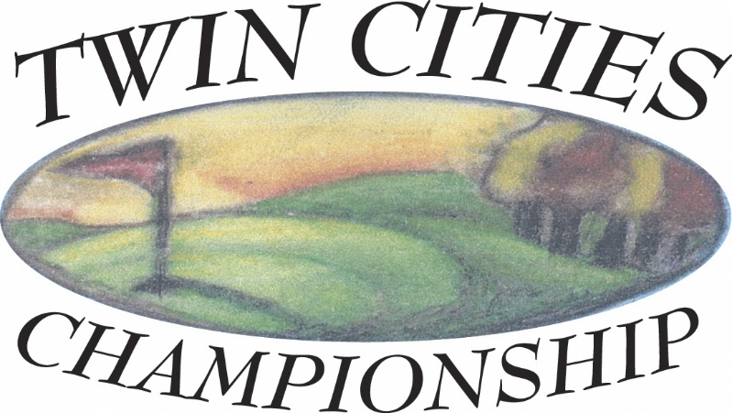

Theodore Wirth Golf Course
Golden Valley, MN

Baker National Golf Course
Independence, MN

June 29-30, 2024

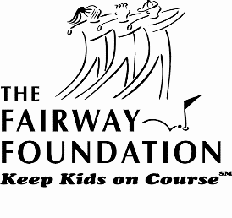
Proceeds to benefit the
Fairway Foundation
www.fairwayfoundation.org

ENTRY DEADLINE: Friday, June 21, 2024

CHAMPIONSHIP PREVIEW
The Twin Cities Championship is a competitive golf tournament that raises money for our selected charity, the Fairway Foundation. This organization, created by the Minnesota Golf Association and the Minnesota Section of the PGA, introduces inner city youth to golf and the benefits that come with the game. Foundation players who complete the program receive scholarships for post high school education

TOURNAMENT FORMAT
Men’s Championship:
This division will play a 36-hole competition with the first day, June 29 at Theodore Wirth Golf Course and the second day, June 30 at Baker National Golf Course. The Champion will be the player with the lowest total gross score for 36 holes. Ties for first place will be played off immediately, hole by hole, until a Champion is determined.

ELIGIBILITY
Open to all amateur players with a maximum USGA handicap index of 5.4 and who are current MGA Associate Members. The USGA’s definition of an amateur golfer is the standard of the Twin Cities Championship. All entries are subject to approval or rejection at any time by the Tournament Committee.

RULES
USGA Rules shall govern play except as amended by the Tournament Committee. Local rules will be printed and issued to each player.

CARTS/CADDIES
Carrying your bag is permissible as is using a pull cart. Motorized carts cannot be used.

ENTRY DEADLINE, ENTRY FEES AND GREENS FEES
Entry forms must be postmarked by June 21 or completed online by that date. An entry fee of $120 must accompany the entry form. Greens fees are included. Late or incomplete entries are not acceptable. Entries by telephone or FAX are not acceptable. Entries with insufficient funds will be considered incomplete and will be withdrawn. The entrant is responsible for any fees incurred by the Twin Cities Championship for INS checks and must pay such fees before entry is allowed.

STARTING TIMES
Assigned starting times can be obtained after noon on Monday, June 24 by accessing the TCC website at www.wirthgolfassociation.org/tcc. and will be emailed to each player

ENTRY WITHDRAWAL AND REFUNDS
Entry fee will be refunded, regardless of reason, if the Twin Cities Championship Tournament Committee is notified in writing before the close of entries. After the close of entries, the entry fee will be refunded in the event of injury or illness only if the Committee is notified by phone at 612/529-0510 by Friday, June 28, 2024, by 4 p.m. If this event is cancelled due to weather, $85 will be refunded, but $35 will be retained by the Tournament Committee because the primary purpose of this event is to raise money for the charity.

PLAYER POINTS AWARDED
Player Points will be awarded to the top three places in the championship.
1st—25 points 2nd—15 points 3rd—10points

PRIZES
The Champion will receive a trophy. Appropriate merchandise certificates will be awarded as determined by the Tournament Committee. Merchandise certificates will be available at the close of play at Baker National GC.

SCORE POSTING
Scores will be posted to the USGA GHIN Handicap System as “T” (Tournament)—scores by the Tournament
Committee.

Application for Entry
33rd
TWIN CITIES CHAMPIONSHIP

THEODORE WIRTH GOLF COURSE
Golden Valley, MN
BAKER NATIONAL GOLF COURSE
Independence, MN

Championship: Saturday and Sunday, June 29-30, 2024

PLEASE PRINT CLEARLY
Name: |__|__|__|__|__|__|__|__|__|__|__|__|__|__|__|__|__|__|__|__|__|__|__|__|__|__|__|__|__|
(First) (Last)
Address: _______________________________________________________________

City: ___________________________ State: __________ Zip Code: ______________

Work Phone: __________________________ Home Phone: ___________________

Email Address: __________________________________________________

Member of: _____________________________________________________________

GHIN Number: __ __ __ __ - __ __ __ Handicap Index: ___________

Amateur status: I have read the USGA Rules of Amateur Status. I conform with those rules in every respect.

Liability: I acknowledge that neither the Twin Cities Championship, Theodore Wirth Golf Course, Baker National Golf Course, Fairway Foundation, nor the event sponsors are responsible for any injury during the playing of this event.

I agree that this entry is subject to rejection at any time (including during the Championship) by the Tournament Committee. The reason for rejection may include unbecoming conduct.

The Tournament Committee will make the pairings and reserves the right to assign the starting times for the Championship.

Make check payable and mail to:
Twin Cities Championship
P.O. Box 11176
Minneapolis, MN 55411
OR
Sign-up online at www.mngolf.org

The entry fee of $120 is enclosed.

ENTRY DEADLINE: Friday, June 21, 2024

Player’s signature: _______________________________________________________

